**Research paper on Arduino Based Home Automation using Bluetooth**

**Ms. Amritpal Kaur Dhillon1**

Chandigarh University Gharuan, Mohali, India

**Bachelors in Computer Science and Engineering Specialization in Information Security AIT-APEX**

**Email: -** [**dhillonamritpalcse1998@gmail.com**](mailto:dhillonamritpalcse1998@gmail.com)

**Email: - 22BIS8001@cuchd.in**

**Abstract: -** The world is rapidly moving towards automation. As people have less time to perform all the tasks, automation is an easy way to manage any product or machine that suits our desires. The purpose of this article is to design and build home automation using Arduino with Bluetooth module. Home automation systems provide simple and reliable tools through Android applications. Fans, lights, air conditioners, automatic door closers, etc. home appliances are controlled by a home automation system using Arduino Uno using Bluetooth modules. This article discusses how smart homes can be monitored and controlled only from Android phones, and how to provide security based on smart homes when people are not at home. The purpose of this article is to manage smart home devices in a user-friendly, low-cost, and easy-to-install method.

**Keywords: -** Arduino, home automation, Bluetooth, smartphone, security

**I. Introduction**

**1. Introduction**

Everyone has a smartphone now and wants to control everything on the smartphone. Everyone knows how to control their phone, so it is easy to use and understand. Lights, fans, switches, and refrigerators, all are controlled using Arduino as a remote control via Bluetooth. Since most people now use smartphones, generating energy at home will become easier and more popular. In this tool, we use Arduino, the most commonly used automation device. Arduino is a device used to connect a computer and a prototype so that we can control it using Arduino programming code. Arduino is a microcontroller that processes data just like the human brain and then performs some logic and math operations on that data. Arduino connects to the Bluetooth module to receive user messages. Arduino is also connected to a relay that receives data from Arduino and performs the conversion. Bluetooth technology is a short-range wireless radio transmission that provides the tools necessary to create intelligence and control. This leads to a personal connection in the home environment where all these devices can be connected and monitored using microcontrollers with Arduino and smartphones. Home automation involves the use of computers or control of certain electrical and electronic components in the home.

**II. Methodology**

**2. Methodology**

Describes the home automation collaboration process; control devices work together to make your home comfortable, customized, efficient, and safe. The device consists of five main components: Arduino, Bluetooth module, relay driver, internal application, and step-down transformer. First, we power the step-down transformer which reduces the input voltage and feeds it to the Arduino via the VIN pin. The Bluetooth module also connects to the Arduino to its Rx and Tx pins to provide data to the microcontroller. The microcontroller reads the data and sends it to the relay driver, which acts as a switch. We load the program into the Arduino as needed and then it does some math and logic to control the relay driver.

The connection between all parts is shown in Figure 2(a). Arduino Bluetooth (HC-05). In Figure 2(b), there are four switches connected to relay drivers and four relays connected to home appliances.

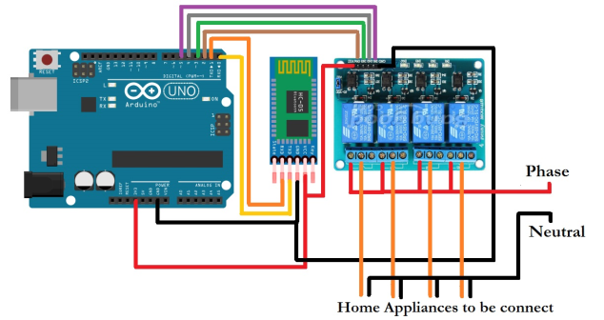

**Fig2(a)-circuit diagram of home automation.**

Android application connected to Arduino Bluetooth (HC-05). In Figure 2(b), there are four switches connected to relay drivers and four relays connected to home appliances.

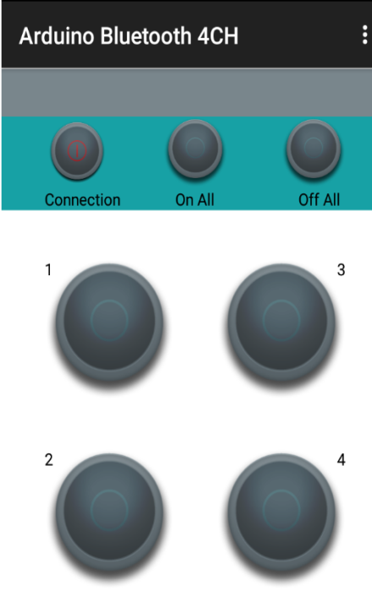

**Fig.2(b)-Mobile Android application.**

**III. Architecture of the Device**

The project is about robotizing machines with the help of Android applications. Nowadays development is the main focus. Any design framework can reduce human effort incredibly, and we can do the same. The architecture of the device is shown in Figure 3(a).

**3. Device Architecture**

This project is about robotizing machines with the help of Android applications. The most important thing now is development. Any design can reduce performance and we can do the same. The architecture of this device is shown in Figure 3(a). This model is highly flexible and scalable, with maximum performance, security, and the added security of smart home devices with minimal personnel. Bluetooth signals have the best power and least harmonics to connect the signal without data loss. The mobile app must have proper connectivity. It should be used together as a multi-purpose device. Set up an Arduino board for any home appliance using the coding on the microcontroller. With the help of a microcontroller, we can control the electrical relay like a switch to receive the signal from Arduino via Bluetooth module HC-05. When the signal is transmitted from the transmitter to the relay as a data table, the relay acts as a switch and controls many smart home devices (multitasking).

1. Arduino Uno

2. Bluetooth HC-05

3. Relay driver

**4. Hardware description**

1. Arduino Uno: - Arduino Uno is a microcontroller chip based on Atmega328 (datasheet) with 14 computerized I/O pins, 6 of which can be used as outputs and 6 as simple information sources. This microcontroller has 32kB ISP flash memory, 2kB RAM, and 1kB EEPROM. The card can communicate via UART, SPI, and 12C. C language, C++ language, etc. in Arduino. We use advanced programming languages ​​such as. Friendly language is easy to understand and use. Multitasking, automation, recording time, etc. It has advantages.

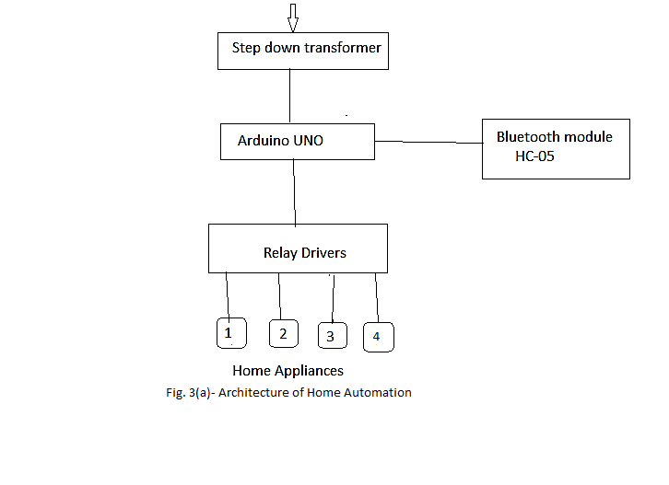

The user will communicate with the Android application via the Arduino Uno via the Bluetooth module. This model is highly flexible and scalable, with maximum performance, security, and the added security of smart home devices with minimal personnel. Bluetooth signals have the best power and least harmonics to connect the signal without data loss. The mobile app must have proper connectivity. It should be used together as a multi-purpose device. Set up an Arduino board for any home appliance using the coding on the microcontroller. With the help of a microcontroller, we can control the electrical relay like a switch to receive the signal from Arduino via Bluetooth module HC-05. When the signal is transmitted from the transmitter to the relay as a data table, the relay acts as a switch and controls many smart home devices (multitasking).

1. Arduino Uno

2. Bluetooth HC-05

3. Relay driver

**4. Hardware description**

**1. Arduino Uno: -**

Arduino Uno is a microcontroller chip based on Atmega328 (datasheet) with 14 computerized I/O pins, 6 of which can be used as outputs and 6 as simple information sources. This microcontroller has 32kB ISP flash memory, 2kB RAM, and 1kB EEPROM. The card can communicate via UART, SPI, and 12C. C language, C++ language, etc. in Arduino. We use advanced programming languages ​​such as. Friendly language is easy to understand and use. Multitasking, automation, recording time, etc. It has advantages.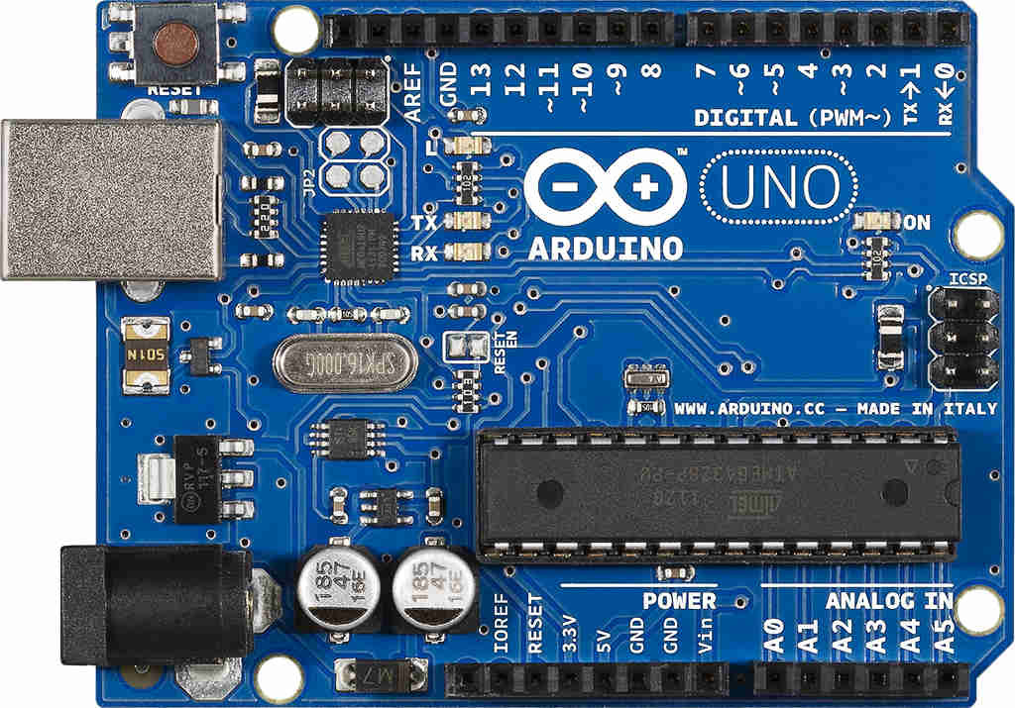

**Fig 4(a)-** Arduino Uno

**2. Bluetooth Module:-**

HC-05 Bluetooth module is used to connect microcontrollers and applications. Bluetooth receives information from the user and sends it to the microcontroller (Arduino Uno). Bluetooth Serial Port Protocol (SSP) is very simple to use and is designed to establish wireless serial connections. The Rx and Tx pins of Bluetooth are connected to the Tx and Rx pins of Arduino respectively. The HC-05 module is an easy-to-use Bluetooth SPP (Serial Port Protocol) module for easy remote integration setup. It uses CSR Blue canter 04-external single-chip Bluetooth function with CMOS innovation and AFH (Adaptive Frequency Hopping Function). Size is approximately 12.7mm x 27mm. **Relay Driver: -**

A relay is an electrical switch used to make an electrical delay and magnetically couple two circuits. When Arduino sends a signal, the relay driver receives the signal and starts working. They are often used to connect electrical circuits (operating at low voltage) to circuits operating at very high voltage. For example, a transformer can convert 5V DC battery power to 230V AC power. This way, for example, a small sensor circuit will drive a fan or a motorized switch. The transformation can be divided into two parts: the data part and the output part. The data field has a loop that creates attraction when a small amount of voltage from the electric current is coupled to the loop. This voltage is called operating voltage. Most devices have 6V, 9V, 12V, 24V etc. There are various operating voltages such as. A simple switch has three contactors: Normally Closed (NC), Normally Open (NO), and Normally Open (COM). When there is no clear information, COM interacts with NC. When the operating voltage is changed, the crimp switch is charged and the COM contacts become normally open. There are many different types of switches, such as SPDT and DPDT, which have different numbers of switches. The circuit can be opened and closed using the appropriate connection of contactors. The relay circuit is shown in Figure 4(c).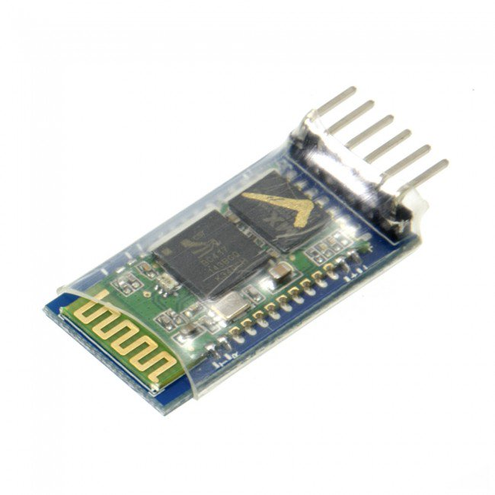

**Fig 4(b) Bluetooth HC-05.**

**3. Relay Drivers:-**

A relay is an electrical switch used to make an electrical delay and magnetically couple two circuits. When Arduino sends a signal, the relay driver receives the signal and starts working. They are often used to connect electrical circuits (operating at low voltage) to circuits operating at very high voltage. For example, a transformer can convert 5V DC battery power to 230V AC power. This way, for example, a small sensor circuit will drive a fan or a motorized switch. The transformation can be divided into two parts: the data part and the output part. The data field has a loop that creates attraction when a small amount of voltage from the electric current is coupled to the loop. This voltage is called operating voltage. Most devices have 6V, 9V, 12V, 24V etc. There are various operating voltages such as. A simple switch has three contactors: Normally Closed (NC), Normally Open (NO), and Normally Open (COM). When there is no clear information, COM interacts with NC. When the operating voltage is changed, the crimp switch is charged and the COM contacts become normally open. There are many different types of switches, such as SPDT and DPDT, which have different numbers of switches. The circuit can be opened and closed using the appropriate connection of contactors. The relay circuit is shown in Figure 4(c). driving transmission. Since the transistor is a power source, the base wire takes adequate current from the emitter to the collector of the transistor. If the source is adequately controlled, the residual transistor is connected from the emitter to the collector and provides energy for switching. When power is sent to the relay, due to the electromagnetic effect, the relay acts as a switch so that we can turn home appliances on and off.

Figure 4(d) of the relay is shown below.

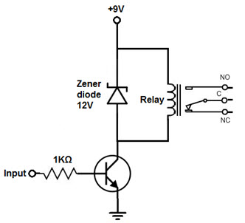

**Fig 4(c) Relay circuit diagram**

We use transistors to achieve switching and can use less power to direct conduction. Since the transistor is a power source, the base wire takes adequate current from the emitter to the collector of the transistor. If the source is adequately controlled, the residual transistor is connected from the emitter to the collector and provides energy for switching. When power is sent to the relay, due to theelectromagnetic effect, the relay acts as a switch so that we can turn home appliances on and off.

The diagram below shows relay scheme 4(d). Advantages

1. It's easy to use because everything is automatic. Since it is controlled via mobile application, there is no need for additional training. We can change management according to our rules. Since it works on an Arduino-based system, we can easily understand how it works. It saves us time. All home appliances can be controlled via an Android app. Easy to install and easy to use.

**VI. Result**

**for. Conclusions**

The conclusions of this article lead to the improvement of home automation according to plan. Thanks to this project, lighting, fans, light bulbs, air conditioners, bulbs, etc. in the house. An automation system was created that allows easy control of the tools. In this article, we also gave information about Arduino Uno, Bluetooth controller, and relay module. and gave information about his work. Home automation products, as well as their advantages, are discussed. The system is easy and safe for users or intruders to access. The final results of this study are shown in Figure 5(a)(b)(c)(d).

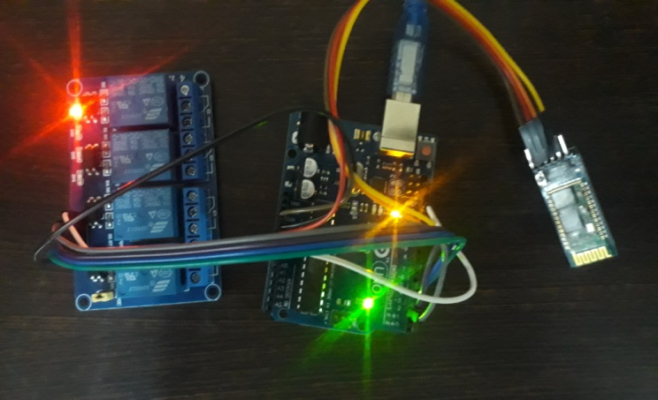

**Fig 5(a) Arduino with relay module**

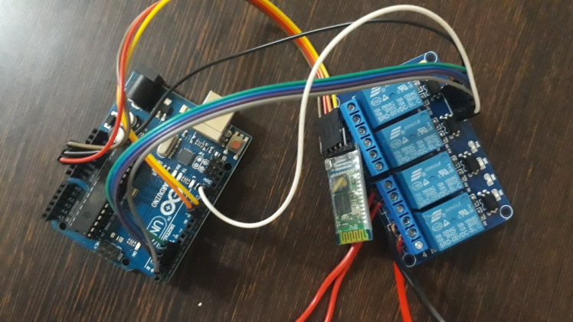

**Fig 5(b) Arduino with Bluetooth**

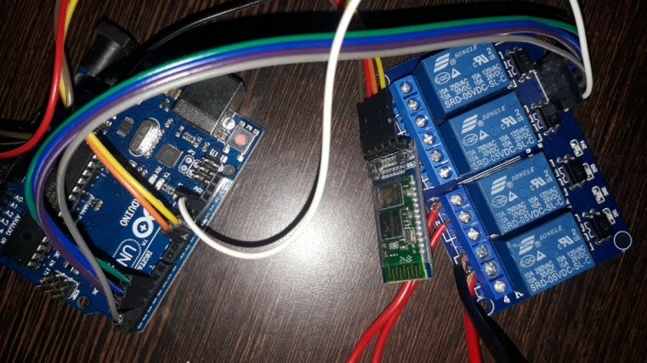

**Fig 5(c) Relay module with Bluetooth**

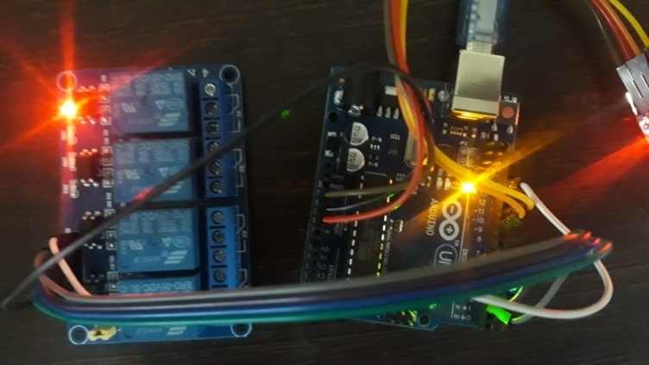

**Fig 5(d) Home Automation**

**VII. Conclusion**

From the above discussion, it can be concluded that home automation is a special tool that requires more effort to manage home appliances. In this article, we show how home automation is used and discussed

About the process and its use. New technologies are being researched, which may include reducing the number of workers in the future, and we are talking about this. We have created a compact-sized, low-cost, capable, long-lasting, wide-receiving device. The need of this research paper is to create a device that saves energy and improves people's lifestyles.

**VIII. References**

[1]. N. David, A. Chima, A. Ugochukwu, and E. Obinna, "Building a home automation system using Arduino", International Journal of Scientific and Engineering Research, Vol. 6, p. 795-801, June 2015. Teacher M. B. Salunke, Darshan Sonar, Nilesh Dangle, SachinKangude, Dattatraya Gawade, "Home automation using cloud computing and mobile devices", Vol. 3. Part 2 (February) 2013), V2 PP 35-37

[3]. A. ElShafee and K. A. Hamed, “Design and implementation of Wi-Fi based home automation system,” World Academy of Science, Engineering, and Technology, vol. 68, p. 2177-2180, 2012. Ahmed Elshafee, Karim Alaa Hamed, "Design and Implementation of Wi-Fi Based Home Automation System", International Journal of Computer, Electrical Automation, Control and Information Engineering, Volume 6, Issue 8, 2012, Nplooj 1074 - 1080.

[6]. Silviu Folea, Daniela Bordencea, Casiana Hotea, Honoriu Valean "Smart home automation system using WiFi low power devices". Mitali Patil, Ashwini Bedare, Varsha Pacharne "Design and implementation of ZigBee based voice controlled wireless smart home automation system". International Journal